STATE ESTABLISHMENT ‘DNIPROPETROVSK MEDICAL ACADEMY OF MINISTRY OF HEALTH OF UKRAINE’

Chair of physical rehabilitation, sport medicine and valeologies

|  |
| --- |
| «Is confirmed»  At methodical meeting of physical rehabilitation, sports medicine and valeology chair  (the chair name)  The head of the chair  __________ Nekhanevich O. B.  « » 20 р. |

METHODICAL INSTRUCTIONS

TO STUDENTS OF ІV  course medical faculty

FOR INDEPENDENT WORK

BY PREPARATION FOR THE PRACTICAL TRAINING

MODULE № 1: PHYSICAL REHABILITATION, SPORT MEDICINE

Thematic module 1: Sport medicine

*Theme № 2:* *Estimation and evaluation of physical development of human.*

Dnipropetrovsk - 2013

MODULE І. PHYSICAL REHABILITATION, SPORT MEDICINE

Thematic module 1: Sport medicine

Theme № 1: *Sport medicine. Complex medical inspection during physical exertion*

1. Theme urgency:

According to the morphological specialities influence on physical work capacity and adaptive abilities the physical development estimation was included into complex medical investigatement.

Theme duration: 4 hours.

1. The educational aim: To find out what sport medicine and physical rehabilitation is. Their practical use and estimation methods.

Concrete aims:

*To know:*

* The main parts of the complex medical investigatement;
* Analyze data of a comprehensive medical examination
* Physiologic endurance features;
* Special medical documents.

*To be able:*

- Analyze data from general and sport anamnesis;

- Analyze data from medical diagnostics;

- describe the results of clinical and laboratory investigations (blood, urine); instrumental methods (ЕCG, Ro);

*To develop practical skills:*

* general and sport anamnesis assembling;
* make physical examination including heart rate and blood pressure definition .
* work with special medical documents.

1. Basic knowledge, skills(interdisciplinary integration) – (table 4.1):

Table 4.1

|  |  |
| --- | --- |
| The names of previous disciplines | Practical skills |
| Normal physiology | To be able to register main physiologic parameters, to know the normal results for different age. |
| Pathologic physiology | To define the development process of prepathologic and pathologic organic changes, non-adequate physical exertion impact |
| Propedeutics of internal disease | To mark height, weight, to take circular perimeter of extremities and body. To evaluate the medical data. |
| Pediatric Propedeutics | To know the specifics of physical development in children according to different age. |

1. Students advice.
   1. Theoretic qestions:

1. Research and evaluation of physical development and functional abilities of the body.

3. Physical performance and its relationship with health indicators.

4. Prepatologic conditions and disease in irrational physical exercise. The concept of doping.

* 1. Practical part:

1. To make the somatoscopy and somatometry to estimate the physical development and to correct of training process;,

2. Decide on access to exercise and to select the most optimal form;

3. Work with medical documents.

Personal physical examination

# Organization_______________________ Kind of sport______________

1. Name ___________________________________________________

2. Date of birth ________ 3. Sex__________ 4. Date________________

5. House address _____________________________________________

6. Living conditions____________ 7. Food mode ___________________

8. Have you ever had: a) an illness_______________________________

b) an injuries________________________________________________

c) an operations______________________________________________

9. Sports qualification_________________________________________

10. Anthropometric measurement:

|  |  |  |  |  |  |  |
| --- | --- | --- | --- | --- | --- | --- |
| Investigation date | | | 1st investigation | 2nd investigation | 3rd investigation | 4th investigation |
| Weight | | |  |  |  |  |
| Height | | |  |  |  |  |
| Chest circumference | pause | |  |  |  |  |
| inspiration | |  |  |  |  |
| expiration | |  |  |  |  |
| range | |  |  |  |  |
| Spirometry | | |  |  |  |  |
| Dynamometry | | Right manus |  |  |  |  |
| Left manus |  |  |  |  |

11. Somatoscopy measurement:

|  |  |
| --- | --- |
| Skin |  |
| Mucous |  |
| Lymphatic |  |
| Fat |  |
| Muscles |  |
| Hernia |  |
| Chest |  |
| Back |  |
| foot |  |

12. Sports anamnesis:__________________________________________________

___________________________________________________________

13. Inspection of internal organs:

1. Complaints _______________________________________________
2. Respiratory system_________________________________________

___________________________________________________________

1. Cardiovascular system______________________________________

___________________________________________________________

1. Digestive system __________________________________________

___________________________________________________________

1. Kidneys, genitalia _________________________________________

___________________________________________________________

1. Endocrine system _________________________________________
2. Other specialists _________________________________________

## Functional tests

|  |  |  |  |  |  |  |
| --- | --- | --- | --- | --- | --- | --- |
| Test’s date | | |  | | | |
| Before loading | Pulses | |  | | | |
| Nature of pulses | |  | | | |
| Blood pressure | |  | | | |
| After loading | Pulses | 10 |  |  |  |  |
| 20 |  |  |  |  |
| 30 |  |  |  |  |
| 40 |  |  |  |  |
| 50 |  |  |  |  |
| 60 |  |  |  |  |
| Blood pressure | |  |  |  |  |
| Nature of pulses | | |  |  |  |  |
| Result | | |  | | | |
|  | | | | | | |

Conclusion:

|  |  |
| --- | --- |
| Physical development |  |
| Health state |  |
| Functional condition |  |
| Medical group |  |
| Pass to training |  |
| Next examination date |  |
| Recommendations |  |

**5.4. Theme content:**

***Somatoscopy***

The inspection should be carried out at direct (or bilateral) illumination on distance of 2-2,5 m. The inspection usually begin from an estimation of skin condition.Duringthe inspection the skin attention should be paid to the colour; eruption of the skin; turgor and elasticity (visual and palpative method); moisture of the skin (visual and palpative method); oedema; subcutaneous vessels. In healthy person skin has corporeal colour (cutis coloris somatici), without eruption, moderate moisture and elasticity, preserved turgor.

**Thickness subcutaneous fat** in differents places of body depends on sex, age, character of nutrition and constitutional features, and professional activity, intensity of exchange processes. At inspection of fat thickness is estimated as expressed poorly, moderate or plentiful*.* The fat can be distributed in tissue uniformly or deposited in only certain parts of the body. Besides a visual estimation, there is a method a fold of skin and fat thickness definition. For this purpose you should take a fold of the skin and fat in 5 sm. ( under a scapulae corner ) and compress it between fingers. In normosthenic person this size is 1,5-2 sm. The thickness more then 2 sm reflects the excessive accumulation of subcutaneous fat, less than 1,5 sm is deficiency, and less than 0,5 sm is the sign of cachexia.

For more sophisticated profile is used skinfold measurement with calipermeter in nine points.

The degree of muscles development is estimated as good, average or weak. Good degree of muscles development is elastic enough, muscles volume is great, and muscles relief is clearly determined even in a quiet condition. Average degree is average volume and elasticity, muscles relief in a quiet condition is expressed poorly, but is determined at a pressure of muscles. Weak degree is volume and elasticity are reduced, muscles relief is not determined even at a pressure of muscles.

**The shape of the chest.** Normal and pathological shapes of the chest are distinguished. There are three normal shapes of the chest: normosthenic (conic), hypersthenic (cylindrical) and asthenic (flat).

Normosthenic (conic) chest: the ribs are moderately inclined, the interspaces are visible, but moderate expressed, epigastric angle is near 90°, the lateral diameter is larger than anteroposterior. Hypersthenic (cylindrical) chest: direction of the ribs are nearly horizontal, the interspaces are narrow and slightly expressed, epigastric angle exceeds 90°, the lateral diameter is about the same as anteroposterior. Asthenic (flat): the ribs direct downward abruptly, more vertical at sides, the 10th ribs are not attached to the costal arch, the interspaces are wide and pronounced, epigastric angle is less than 90°.

Pathological shapes of the chest can be caused either by chronic diseases of the lung and pleura (emphysematous, paralytic chest), or by various deformities of the spine (scoliosis, kyphosis, lordosis) and other diseases. (Figure 1):

* Paralytic chest – the same signs that peculiar to the asthenic chest but more pronounced. The ribs are vertical, the interspaces are wide and depressed, marked atrophy of the chest muscles;
* Rachitic or pigeon chest (Pectus cardinatum)is a result of abnormal skeleton formation in childhood in the patients with rachitis. The sternum is displaced anteriorly, increasing anteroposterior diameter, resembling the keel of the boat;
* Funnel chest (Pectus excavatum) is characterised by a depression in the lower portion of the sternum;
* Emphysematous or barrel chest– supra- and infraclavicular fossae are absent, direction of the ribs are horizontal, the interspaces are narrow and slightly expressed, epigastric angle exceeds 90°, the lateral diameter is about the same as anteroposterior.

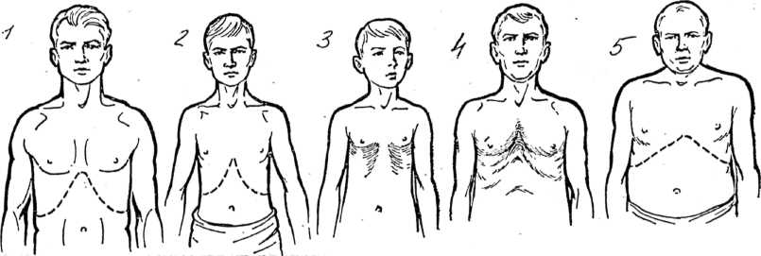

Figure 1. Different shapes of the chest.

*1 – normosthenic; 2 – flat; 3 – rachitic; 4 – funnel; 5 –*emphysematous*.*

**The shapes of the back** depends on spine condition. (figure 2) There are normal and different pathological shapes of the back:round, round-concave, flat.

normal back– there are four physiological curvature of the spine: cervical and lumbar curvatures with forward convexity - lordosis; thoracic and pelvic curvatures with backward convexity – kyphosis. The depth of these curvatures makes in norm 3-4 sm.

* roundback is characterised by increase of backward curvature in thoracic part of spine.
* round-concavebackis characterised by increase of backward curvature in thoracic and forward curvature in lumbar parts of spine.
* Flat backis marked when the smoothing of curvatures takes place.

The lateral curvatures of the spine are called scoliosis. (figure 3).

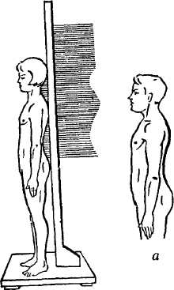 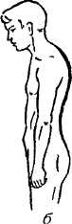 

a b c d

Figure 2. The shapes of the back.

*а – normal; b – round; c - flat; d – round-concave.*

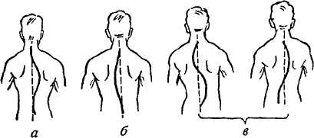

Figure 3. Kinds of the scoliosis.

*а – rightward; б – leftward; в* – *S-ward.*

**The shape of the low extremities.** There is correct form of the legs, when the longitudinal axis of femur andcruse are the same and internal surfaces of the knees and talocruraris joints are contacts. X-model legs: if the internal surfaces of the knees are contacts but talocruraris joints haven't contacts; O-model legs: if the internal surfaces of the knees haven’t contacts but talocruraris joints are contacts (figure 4,5). Deviation more then 5 sm is deep degree deformation of the leg.

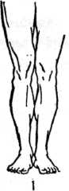 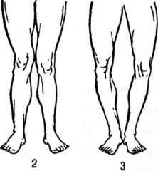

Figure 4. The shape of the legs: *1 – normal; 2 – Х-similar; 3 - О-similar;.*

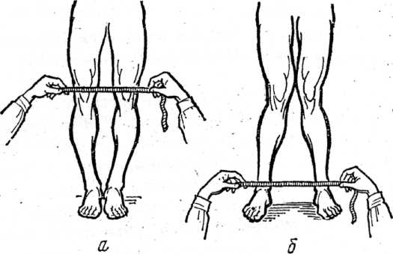

Figure 5. Estimation of the legs deviation degree.

**The shapes of the foot.** There are correct (vaulted), high, flat the shapes of the foot:

* correct (vaulted) of the foot*:* there is narrow isthmus between heel and anterior part of the foot (1/3 of the foot's wide);
* *high foot:* the heel and anterior part of the foot haven’t isthmus;
* *flat –* isthmus is more then 2/3 of the foot’s wide.

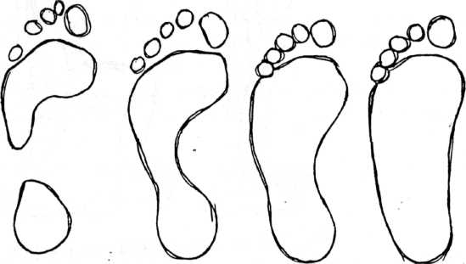

a b c

Figure 6. The shapes of the foot.

*а – high, b – correct, c – flat.*

**Constitutional tips:** normosthenical, asthenical, hypersthenical aredefined according to longitudinals and transversals diameters of the body.

**Anthropometry**

**Measurement of the weight.** The weight is measured on a special medical balance weight should be done in the morning. Patient should be with no clothes. In order to follow changes the patient’s weight repeated weightings should be done in the same conditions.

**Measurement of the height.** The height is measured in sitting and standing positions with the heightmeter (antropometer). When we measure the standing height the patient stands on the heightmeter’s platform, touches his heels, gluteus and interscapula area with heightmeter’s post with scale. Position of the head: upper edge of the ductus auricular external and lower orbital edge must to lie on horizontal line. When we measure the sitting height the patient sits down on the heightmeter’s platform, touches his sacrum and interscapula area with heightmeter’s post with scale. Position of the head must be the same (figure 7).

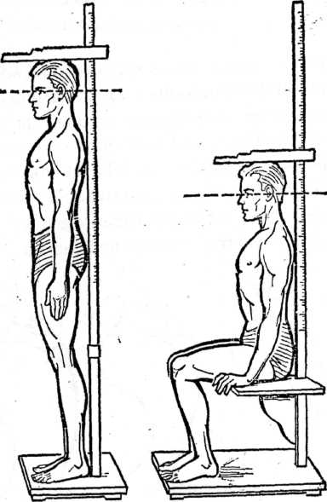

Figure 7. The height measurement with heightmeter.

**Measurement the chest’s circumference.** It’s performed by centimeter ribbon in positions: rest, maximal inspiration and maximal expiration. The difference between these indexes is range of the chest.

*Methodic of the measurement.* The patient abducts the hands. The centimeter ribbon put on around the chest: on the back under lower angle the scapulae, in front of the chest in the point where the IV ribs fixation to the sternum. The patient is adducting hands, when the centimeter ribbon put on.

**Spirometry.** It’s used to assess vital capacity (VC). VC is the largest volume of air that can be expired after full inspiration.

*Methodic of the measurement.* The patient makes 1-2 deep respiration. After that he makes maximal inspiration and then expires in the spirometer all the air. The patient makes this three times, with a short rest period between each attempt. We take maximal index.

**Dynamometry.**  The purpose of the tests is to determine the maximum force that can be generated by the muscles. There are manus dynamometry (to assess the manus muscles strength) and trunk dynamometry (to assess back muscles strength).

*Methodic of the manus dynamometry.* The patient takes dynamometer in the manus, abducts the hand and maximal compresses of the dynamometer. The patient makes this three times, with a short rest period between each attempt. We take maximal index.

*Methodic of the trunk dynamometry.* The patient stands on special platform with hook to fixation dynamometer. The hook must be in middle of the foot. The dynamometer must be in the middle of the knees. The patient slowly extends. This procedure is performed one time. Contraindication: pregnancy, menses, hernias, deep arthrosis.

* 1. Self-control materials:

1. ***self-control questions***

1. The complex medical investigation methodic by patients who are training, the kinds of investigations.

2. The receipts of common and sport anamnesis peculiarities.

3. The common investigation of organs and systems peculiarities.

4. The dates percussion and auscultation by sportsmen of hart analyze and estimation. The physiological criterions of training persons.

5. «The physical development» definition. The physical development influence factors.

6. The methods of physical development investigation (somatoscopy and anthropometry).

7. The methods of physical development estimation (standards, anthropometrical structure and indexes).

8. The physical development harmonization and correction recommendations.

***2) Тests:***

1. Functional systolic murmur after exercise tolerance test:

A. Doesn’t change,

B. Weakens and disappears,

C. Intensifies or weakens,

D. Intensifies,

E. Changes the timbre.

2. Healthy not trained males breath holding time at inhaling (Shtange test) ranges:

A. 40-60 seconds,

B. 50-60 seconds,

C. 20-30 seconds,

D. 40-50 seconds,

E. 20-40 seconds.

3. Orthostatic sign allows us to estimate functional condition of:

A. Parasympathetic vegetative nervous system,

B. Central nervous system,

C. Cardiovascular system,

D. Sympathetic vegetative nervous system,

E. Vegetative nervous system.

***3) Clinical mind improvement***

While physical examination of student К., age 23 was estimated: height – 182 sм, weight – 93 kg, chest circumference – 100 sm, LVC – 3000 ml, hand dynamometry R – 30 kg and L - 28 kg back muscular force – 100 kg.

1. what method was used to examine the physical development?

2. What should be done to evaluate the physical development?

3. What is the level of physical development? Is it harmonious?

4. Give the conclusion and recomendations.

literature:

1. Remedial gymnastics and sport medicine: textbook/ Klapchuk V.V., Dsiak G.V., Mutavov V.I.; red. Klapchuk V.V., Dsiak G.V. – К.: Zdorov`e, 1995. – 312 p.
2. Remedial gymnastics and sport medicine: Tests for knowlage control in students of medical and stomatological faculties of universitie ІУ level of acreditation / Abramov В.В., Klapchuk В.В., Magl`ovanuy А.V., Smirnova О.L.,; red. Ph. Klapchuk V.V., Ph. Magl`ovanuy А.V. – Dnipropetrovsk: medical academy, 2006. – 124 p.
3. Remedial gymnastics and sport medicine (Lections) / Abramov В.В., Klapchuk V.V Smirnova О.L.,.; red. Ph. Klapchuk V.V.,– Dnipropetrovsk: medical academy, 2006. – 179 p
4. Medical control in physical training and sports: medical recommendations for students of medical and stomatological faculties of universitie ІУ level of acreditation / V.S. Sokolovskyy, N.А. Romanova, V.S. Vladova, I.I. Bondarev. – Odessa: osmu, 2001. – 93p.
5. Sport medicine. textbook / Makarova G.А. – М.: Soviet sport, 2003. – 480 p.
6. Textbook «Remedial gymnastics and medical control» red. Epifanova and G. L. Apanasenko –p.14-16, 25-37.
7. Functional tests in sport medicine (methodical recomendations) /Mychaluk E. L. –Kyiv. –2005. –37p.

Discussed on chair meeting «____»___________20___р. (Protocol № ____)

The head of the chair, Phd. _________________ О.B.Nekhanevich

Discussed on chair meeting «____»___________20___р. (Protocol № ____)

The head of the c**hair**, Phd. _________________ О.B.Nekhanevich